INTRODUCTION TO CYBERSECURITY

NETWORKING TECHNOLOGIES
TASK1: Draw a simple network diagram showing how your smartphone connects to Instagram — include your device, Wi-Fi router, ISP, and Instagram's server, and label each part.
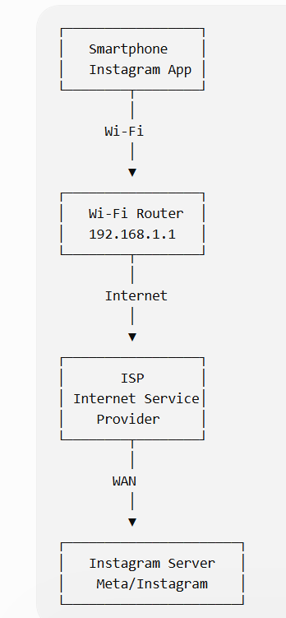
- My smartphone connects to the Wi-Fi router wirelessly.
- The router sends the data to the ISP through the internet connection.
- The ISP forwards the request through the Internet.
- The request reaches the Instagram server.
- Instagram sends the requested data back through the same network path.
TASK2: List the IP address of your device and your default gateway using the 'ipconfig' command (Windows) or 'ifconfig' (Linux/Mac), and explain what each means in 1-2 lines.
- Press Windows + R.
- Type: cmd
- Press Enter.
- Type: ipconfig
- Press Enter.
- Find your active Wi-Fi or Ethernet adapter.
- Look for:
• IPv4 Address
• Default Gateway

EXAMPLE:
IPv4 Address..........: 192.168.1.10
Subnet Mask...........: 255.255.255.0
Default Gateway.......: 192.168.1.1

TASK3: Simulate a Zomato food order journey by writing the steps/data packets that travel from your device to Zomato's server and back, mentioning protocols like HTTP, TCP/IP, and DNS wherever relevant.<br><br><em><strong>Hint:</strong> Think about what happens when you search for a restaurant and place an order.</em>
- I open the Zomato app on my smartphone.
- I search for a restaurant or food item.
- The device first uses DNS to find the IP address of Zomato's server.
- A connection is established using TCP/IP.
- The app sends my search request to the Zomato server using secure web communication.
- The Zomato server processes the request and sends the restaurant/food information back to my phone.
- I select the food and place the order.
- My order information is sent to the Zomato server.
- The server processes the order and sends the confirmation back to my device.
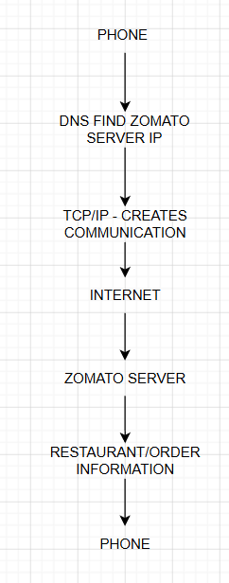
TASK4: Use the 'ping' command to check the connection between your computer and www.spotify.com, then explain what the results mean for network troubleshooting.
- Open Command Prompt.
- Type: ping www.spotify.com
- Press Enter.
- Wait for the results.
